ANTIMICROBIAL PROPERTIES OF TOMATO JUICE AND PINEAPPLE JUICE AGAINST TYPHOIDAL SALMONELLA AND RHIZOPUS
BY

ALADEMEHIN ELIZABETH AYOBAMI
H/ST/23/2664

DEPARTMENT OF SCIENCE LABORATORY TECHNOLOGY (MICROBIOLOGY), SCHOOL OF PURE AND APPLIED SCIENCES, THE FEDERAL POLYTECHNIC, ILARO.

SEPTEMBER, 2025.
ANTIMICROBIAL PROPERTIES OF TOMATO JUICE AND PINEAPPLE JUICE AGAINST TYPHOIDAL SALMONELLA AND RHIZOPUS
BY

ALADEMEHIN ELIZABETH AYOBAMI
H/ST/23/2664

A PROJECT REPORT SUBMITTED IN PARTIAL FULFILMENT OF THE REQUIREMENTS FOR THE AWARD OF HIGHER NATIONAL DIPLOMA IN THE DEPARTMENT OF SCIENCE LABORATORY TECHNOLOGY (MICROBIOLOGY), SCHOOLOF PURE AND APPLIED SCIENCES, THE FEDERAL POLYTECHNIC, ILARO.

SEPTEMBER, 2025.
CERTIFICATION
This is to certify that this project report was carried out by ALADEMEHIN ELIZABETH AYOBAMI with matriculation number H/ST/23/2664 under the supervision of MRS F.O ABDUSSALAM in the Department of Science Laboratory Technology of The Federal Polytechnic Ilaro, Ogun state.

___________________________
Supervisor’s signature and date.

____________________________
Head of Departments signature and date.

DEDICATION
This project is dedicated to God Almighty, the source of knowledge that made the completion of this research work possible.

ACKNOWLEDGEMENT
All praise and gratitude are due to God, the Most Merciful an the Most Beneficent, for granting me the strength, wisdom, and perseverance to complete this project successfully.
Without His divine guidance, this work would not have been possible. I extend my heartfelt appreciation to my beloved parents, Mr. and Mrs. Alademehin, for their unwavering love, prayers, and support throughout my academic journey. Their sacrifices and encouragement have been my greatest motivation.
I am also deeply grateful to my supervisor, Mrs. F.O. ABDUSSALAM for her invaluable guidance, patience, and insightful feedback, which have greatly contributed to the completion of this project.
I would also like to express my sincere appreciation to my amazing friends, who have supported me in countless ways, offering both academic and moral support. Your companionship has made this journey enjoyable and fulfilling.
Finally, I extend my gratitude to my course mates for their collaboration, motivation, and shared experiences, which have made my academic pursuit both enriching and memorable.
May God bless you all abundantly

ABSTRACT
This study investigated the antimicrobial properties of pineapple (Ananas comosus) and tomato (Solanum lycopersicum) juices against selected bacterial and fungal pathogens, with emphasis on Escherichia coli and Candida albican. The extracts were prepared at varying concentrations (100%, 75%, 50%, and 25%) and tested using the agar well diffusion method, while ciprofloxacin and fluconazole served as positive controls and distilled water as the negative control. Results revealed that pineapple extract exhibited the highest antibacterial activity against E. coli at 75 mg/ml with a 10 mm inhibition zone, whereas tomato extract showed moderate activity at the same concentration with 5 mm inhibition. Against Candida albican, tomato extract demonstrated the strongest antifungal activity at 100 mg/ml (10 mm), while pineapple was most effective at 25 mg/ml (6 mm). Minimum inhibitory concentration (MIC) tests confirmed that both extracts inhibited E. coli at 75 mg/ml, while pineapple inhibited Candida albican at 25 mg/ml compared to 50 mg/ml for tomato. Statistical analysis expressed as mean ± standard deviation supported the concentration-dependent trends observed. Although the extracts exhibited notable antimicrobial potential, their activity was less pronounced than standard drugs, highlighting their possible role as complementary or alternative agents. The findings suggest that the bioactive components of pineapple and tomato could be further explored, isolated, and standardized to develop natural antimicrobial formulations that may serve as affordable and accessible alternatives in managing microbial infections, especially in the face of rising antibiotic resistance.

TABLE OF CONTENTS
Cover page i
Title Page ii
Certification iii
Dedication iv
Acknowledgement v
Abstract vi
Table of Contents vii
List of Tables xi
List of Figures xii
List of Plates xiii
CHAPTER ONE 1
1.0 Introduction 1
1.1 Background to the Study 1
1.2 Statement of the Problem 6
1.3 Justification of the Study 7
1.4 Aim and Objectives of the Study 8
1.4.1 Aim of the Study 8
1.4.2 Objectives of the Study 8

CHAPTER TWO 9
2.0 Literature Review 9
2.1 Concept of Antimicrobial Agents 9
2.2 Antimicrobial Resistance and Public Health Challenges 10
2.2.1 Antibiotic Resistance in Salmonella Typhi 11
2.2.2 Antifungal Resistance in Rhizopus spp 12
2.2.3 Public Health Implications of AMR 13
2.3 Bioactive Compounds in Tomato and Pineapple 13
2.3.1 Phytochemicals in Tomato 14
2.3.2 Phytochemicals in Pineapple 14
2.3.3 Synergistic Potential of Combined Extracts 15
2.4 Mechanisms of Antimicrobial Action of Fruit Juices 15
2.4.1 Disruption of Cell Membranes 16
2.4.2 Inhibition of Enzymatic Activity 16
2.4.3 Oxidative Stress Induction 17
2.5 Empirical Evidence of Antimicrobial Activities of Fruit Juices 17
2.5.1 Evidence of Antibacterial Activity of Tomato Juice 18
2.5.2 Evidence of Antifungal Activity of Pineapple Juice 19
2.5.3 Synergistic Empirical Studies 19

CHAPTER THREE 20
3.0 Materials and Methods 20
3.1 Materials 20
3.1.1 Sample Collection 20
3.1.2 Reagents 21
3.2 Methods 21
3.2.1 Preparation of Nutrient Agar 21
3.2.2 Preparation of Sabouraud Dextrose Agar 21
3.2.3 Preparation of Plant Extracts 21
3.2.4 Preparation of Test Organisms 23
3.2.5 Antimicrobial Susceptibility Testing (Agar Well Diffusion Method) 23
3.2.6 Minimum Inhibitory Concentration (MIC) Test 23
CHAPTER FOUR 24
4.0 Results and Discussion 24
4.1 Results 24
4.1.1 Statistical Analysis 31
4.2 Discussion 34
4.2.1 Antimicrobial Activity Against E. coli 34
4.2.2 Antimicrobial Activity Against Candida albican 43
4.2.3 Minimum Inhibitory Concentration (MIC) 48
CHAPTER FIVE 50
5.0 Conclusion and Recommendation 50
5.1 Conclusion 50
5.2 Recommendation 51
REFERENCES 53

LIST OF TABLES
Table 4.1: Antimicrobial activity of the extract obtained from pineapple and tomato against E. coli 26
Table 4.2: Antimicrobial activity of the extract obtained from pineapple and tomato against Candida albican 28
Table 4.3: MIC test for pineapple and tomato extracts against E. coli and Candida albican 30

LIST OF FIGURES
Figure 2.1: Antibiotic Resistance in Salmonella Typhi 11
Figure 2.2: Antifungal Resistance in Rhizopus spp 12
Figure 2.3: Disruption of Cell Membranes 17
Figure 3.1: Sayedero Market Map 20
Figure 3.2: Pineapple and Tomato Extracted 22
Figure 4.1: Antibacterial Activity Against Escherichia coli 32
Figure 4.2: Antifungal Activity Against Candida albican 33

LIST OF PLATES
Plate 4.1: E.coil Pineapple 37
Plate 4.2: E.coil Pineapple 38
Plate 4.3: E.coil Tomato 41
Plate 4.4: E.coil Tomato 42
Plate 4.5: Fungi Candida albican: Pineapple and Tomato 47

CHAPTER ONE
1.0 INTRODUCTION
1.1 Background to the Study
In recent decades, the emergence of antibiotic-resistant pathogens has posed significant challenges to public health worldwide. Salmonella enterica serovar Typhi, the causative agent of typhoid fever, remains a persistent threat in regions with inadequate sanitation and hygiene practices. Concurrently, fungal infections caused by species within the genus Rhizopus have been increasingly reported, particularly in immunocompromised individuals and those with underlying health conditions.
The search for alternative antimicrobial agents has intensified, driven by the need for effective treatments against multidrug-resistant pathogens. Natural products, including fruit juices, have garnered attention due to their diverse bioactive compounds with potential antimicrobial properties. Among these, tomato (Solanum lycopersicum) and pineapple (Ananas comosus) juices have been identified as promising candidates for their inherent biochemical composition.
The persistent threat posed by microbial pathogens, particularly those with multidrug resistance, has driven global attention toward the discovery and validation of alternative therapeutic options, especially from natural sources. Infectious diseases remain one of the leading causes of morbidity and mortality worldwide, with bacterial and fungal infections representing significant clinical and public health challenges. Among these pathogens, Salmonella enterica serovar Typhi, the causative agent of typhoid fever, and Rhizopus spp., a genus of zygomycetous fungi often implicated in mucormycosis, have gained increased attention due to their prevalence and resistance profiles. The emergence of multidrug-resistant strains of Salmonella Typhi and the opportunistic nature of Rhizopus in immunocompromised individuals have intensified the search for new antimicrobial compounds (Hendriksen et al., 2011; Petrikkos et al., 2012). These concerns warrant the exploration of plant-derived products as feasible, accessible, and cost-effective antimicrobial alternatives.
Tomato (Solanum lycopersicum) and pineapple (Ananas comosus) are two fruits renowned for their rich nutritional value and diverse phytochemical composition. Traditionally consumed for their flavor and health benefits, these fruits are increasingly being explored for their antimicrobial properties. Tomato juice is a rich source of lycopene, flavonoids, phenolic acids, and other antioxidants known to exhibit antibacterial effects (Giovannucci, 2002). Pineapple juice, on the other hand, contains bromelain a proteolytic enzyme with demonstrated antimicrobial and anti-inflammatory properties as well as organic acids and flavonoids that contribute to its broad-spectrum bioactivity (Hale et al., 2005). Several studies have reported the antibacterial activity of these fruit extracts against both Gram-positive and Gram-negative bacteria, as well as certain fungi (Duarte et al., 2005; Kaur & Arora, 2009).
The global burden of typhoid fever, particularly in developing countries like Nigeria, underscores the need for urgent and innovative interventions. Typhoidal Salmonella continues to pose a major health challenge in sub-Saharan Africa due to poor sanitation, unsafe water supply, and increasing antimicrobial resistance (Crump et al., 2004). Infections with Salmonella Typhi are characterized by prolonged fever, abdominal discomfort, hepatosplenomegaly, and in severe cases, intestinal perforation and death. Conventional treatments with antibiotics such as chloramphenicol, ciprofloxacin, and ceftriaxone are becoming increasingly ineffective due to resistant strains (Kariuki et al., 2006). These developments have heightened interest in the antimicrobial activity of naturally occurring substances, such as tomato and pineapple juices, as adjunct or alternative remedies.
On the fungal side, Rhizopus species are saprophytic fungi that become pathogenic under immunocompromised conditions, such as diabetes mellitus, leukemia, or post-organ transplant states. The fungal spores are widespread in the environment, and once inhaled or ingested, can lead to life-threatening infections such as rhinocerebral and gastrointestinal mucormycosis (Ibrahim et al., 2012). Treating Rhizopus infections is often complicated due to the aggressive nature of the pathogen, high treatment costs, and limited efficacy of existing antifungal agents like amphotericin B. The toxicity associated with antifungal drugs further necessitates the exploration of less toxic, plant-based options that are readily available and culturally acceptable.
Over the years, plant-based research has flourished as scientists investigate the phytochemical constituents of various fruits and vegetables for their antimicrobial potential. Secondary metabolites such as alkaloids, saponins, tannins, and terpenoids have been shown to disrupt microbial cell walls, inhibit protein synthesis, or interfere with microbial enzyme function (Cowan, 1999). The use of food-grade fruit juices such as tomato and pineapple offer the additional advantage of safety, affordability, and ease of administration. As both juices are rich in organic acids, their low pH environment may also contribute to microbial inhibition, particularly of acid-sensitive bacteria and fungi (Jay, 2000).
Several studies have demonstrated that natural juices can be effective against a broad range of pathogens, and may even outperform synthetic antibiotics in specific conditions. For instance, Kothari et al. (2012) showed that aqueous and ethanol extracts of tomato significantly inhibited the growth of E. coli and Staphylococcus aureus. Similarly, pineapple juice has been reported to exhibit potent antimicrobial effects against pathogens such as Helicobacter pylori, Candida albicans, and Streptococcus mutans (Umesh et al., 2010). However, data specific to their activity against typhoidal Salmonella and Rhizopus are relatively scarce, highlighting a research gap that this study intends to address.
Furthermore, the use of fruit juices in microbial inhibition is aligned with the current shift towards natural and organic antimicrobial agents. With growing public health campaigns advocating reduced antibiotic consumption and a return to traditional remedies, studies like this are not only timely but critical. They validate or refute age-old practices with scientific rigor and offer potential for novel antimicrobial drug discovery. More so, the application of such juices can be optimized in food preservation, therapeutic formulations, and hygiene products.
The interest in natural antimicrobial agents is also spurred by the global trend of antimicrobial stewardship a coordinated effort to reduce the emergence of resistant strains through prudent use of antibiotics and the integration of alternative treatments. In this light, tomato and pineapple juices could be developed into standardized formulations, either as stand-alone treatments or as complements to existing antibiotics, thereby contributing to the preservation of antibiotic efficacy (Ventola, 2015). This is particularly important for resource-constrained settings where access to modern medications is limited.
In Nigerian traditional medicine, fruits like tomato and pineapple are often used in managing infections, albeit with anecdotal support. These practices merit scientific validation through in vitro and in vivo studies. Establishing the efficacy of these juices against known pathogens will not only improve local healthcare strategies but also create opportunities for pharmaceutical exploitation. Such approaches can reduce the over-reliance on synthetic drugs and promote sustainable health interventions based on indigenous knowledge.
It is important to note that the antimicrobial effect of plant-based products depends on a multitude of factors, including the part of the plant used, the solvent for extraction, concentration, and the microbial strain tested. These variables will be carefully considered in the present study to ensure reproducibility and relevance of findings. Furthermore, standardized methods of antimicrobial susceptibility testing, such as the agar well diffusion and broth dilution methods, will be employed to evaluate the activity of the fruit juices under controlled laboratory conditions (CLSI, 2020).
Despite promising in vitro results from related studies, challenges remain in translating these findings into clinical applications. Questions about bioavailability, toxicity at high concentrations, and stability over time remain unresolved. However, such challenges should not deter scientific inquiry but rather encourage more nuanced investigations that bridge the gap between laboratory research and practical application.
This study, therefore, seeks to investigate the antimicrobial properties of tomato and pineapple juices against Salmonella Typhi and Rhizopus spp. by evaluating their inhibitory effects under laboratory conditions. The aim is to provide empirical evidence that supports or challenges the use of these natural products in the management of bacterial and fungal infections. Through this, we hope to contribute to the growing body of research advocating for sustainable, accessible, and effective antimicrobial alternatives.
In addition, this research has implications for food safety and public health, especially considering the widespread consumption of these fruits. If the juices prove effective, they may be used in the development of natural preservatives, surface disinfectants, or even therapeutic drinks tailored for antimicrobial prophylaxis. This would mark a significant advancement in both preventive and curative health strategies.
In summary, the study will address key questions about the antimicrobial activity of common fruit juices against clinically relevant pathogens. It aligns with global health goals that promote innovation, inclusivity, and sustainability in healthcare delivery. It also offers an avenue to bridge the gap between traditional knowledge and modern science by validating the bioactive potential of indigenous food items through standardized laboratory procedures.
1.2 Statement of the Problem
The increasing prevalence of antimicrobial-resistant pathogens has become a significant global health concern, particularly in developing nations where healthcare access is limited and the cost of effective treatment is often prohibitive (World Health Organization [WHO], 2022). Among these pathogens, Salmonella enterica serovar Typhi (causing typhoid fever) has demonstrated growing resistance to commonly prescribed antibiotics such as ciprofloxacin and ampicillin, making standard treatments less effective (Parry et al., 2021). Similarly, Rhizopus species, responsible for mucormycosis (a rapidly progressing fungal infection), have shown resistance to first-line antifungal therapies like amphotericin B, especially in immunocompromised patients, such as those with diabetes or undergoing chemotherapy (Ibrahim et al., 2020).
The overreliance on synthetic antimicrobial drugs has contributed significantly to the emergence of resistant strains. This resistance trend is further fueled by indiscriminate and prolonged use of antimicrobials in both clinical and agricultural settings (Ventola, 2015). In light of these challenges, there is an urgent need to explore and validate alternative, naturally derived antimicrobial agents that can complement or substitute conventional treatments.
Tomato (Solanum lycopersicum) and pineapple (Ananas comosus) are fruits that are not only rich in nutrients but also known to contain bioactive compounds such as flavonoids, tannins, and organic acids that may exhibit antimicrobial activity (Ali et al., 2022; Singh & Prasad, 2021). Despite their widespread consumption and anecdotal use in traditional medicine, scientific literature on their specific antimicrobial effects against typhoidal Salmonella and Rhizopus species remains limited.
In many rural communities, where pharmaceutical resources are scarce and antimicrobial resistance is prevalent, the availability of natural and inexpensive antimicrobial options could have a transformative impact on public health. However, the absence of empirical data validating the effectiveness of tomato and pineapple juices against clinically significant pathogens such as S. Typhi and Rhizopus limits their consideration in formal healthcare systems (Yadav et al., 2023).
Hence, the core problem addressed in this study is the lack of scientific evidence on the antimicrobial efficacy of tomato and pineapple juices against typhoidal Salmonella and Rhizopus spp. This investigation seeks to fill that gap by evaluating the potential of these juices as alternative antimicrobial agents. This could open up new frontiers in preventive and curative medicine, especially in environments where conventional treatments are either ineffective or unaffordable.
1.3 Justification of the Study
With the rising incidence of infections caused by typhoidal salmonella and related bacteria, there is a critical demand for effective antimicrobial solutions. Utilizing natural juices like tomato and pineapple not only presents a potential alternative to synthetic preservatives but also aligns with the growing consumer preference for natural and healthy food options.
The study is also justified by the broader global call by the World Health Organization (WHO, 2022) and Food and Agriculture Organization (FAO) for integrated approaches to combating antimicrobial resistance through the discovery and validation of plant-based antimicrobials. By focusing on common fruits that are easily available and widely accepted in dietary practices, this study aligns with public health goals to promote preventive healthcare using functional foods with therapeutic potential.
Also, understanding the antimicrobial properties of these juices can contribute to the development of innovative food preservation techniques that could reduce the risk of contamination and enhance food quality (Kahn & Kahn, 2015).
1.4 Aim and Objectives of the Study
1.4.1 Aim of the Study
The aim of the study is to evaluate the antimicrobial properties of tomato juice and pineapple juice against typhoidal salmonella and Rhizopus.
1.4.2 Objectives of the Study
The objectives of this work are to:
- To evaluate the antimicrobial activities of the extracts against multidrug resistant strain of typhoidal salmonella and Rhizopus.
- To compare the effect of the tomato and pineapple extracts against multidrug resistant microorganisms.
- To compare the antimicrobial activity of tomato juice and pineapple juice against the selected microorganisms.
- To determine the minimum inhibitory concentration (MIC) of tomato juice and pineapple juice required to inhibit the growth of the selected microorganisms.

CHAPTER TWO
2.0 LITERATURE REVIEW
2.1 Concept of Antimicrobial Agents
Antimicrobial agents refer to substances that either kill or inhibit the growth of microorganisms, including bacteria, fungi, viruses, and protozoa. These agents may be naturally occurring (as in the case of certain plant extracts), synthetic (e.g., ciprofloxacin), or semi-synthetic (e.g., amoxicillin). The relevance of antimicrobial agents has dramatically increased in recent years due to the emergence of resistant strains of bacteria and fungi that no longer respond to conventional treatments. According to the World Health Organization (2022), antimicrobial resistance (AMR) is now one of the top ten global public health threats. This calls for the urgent identification and application of novel antimicrobial sources that are both effective and safe.
Natural products, especially plant-derived compounds, have gained attention as promising alternatives due to their broad-spectrum activity and minimal side effects (Suresh et al., 2021). Fruits such as tomatoes and pineapples are known to contain diverse phytochemicals phenolics, flavonoids, alkaloids, and organic acids that exhibit antimicrobial potential. Studies suggest that these natural compounds disrupt microbial cell membranes, interfere with DNA replication, or inhibit essential enzymatic activity (Yadav et al., 2023). The concept of antimicrobial agents, therefore, extends beyond laboratory-manufactured drugs to encompass everyday food items that may harbor potent antimicrobial capabilities.
Understanding the concept of antimicrobial agents is fundamental to this study, which investigates the potential of tomato and pineapple juices against Salmonella Typhi and Rhizopus. Establishing the antimicrobial characteristics of these juices may pave the way for their inclusion in preventive or therapeutic protocols. Furthermore, by focusing on naturally derived substances, the study aligns with the global initiative for sustainable healthcare and the development of eco-friendly antimicrobial products.
2.2 Antimicrobial Resistance and Public Health Challenges
Antimicrobial resistance (AMR) poses a major challenge to global health, reducing the efficacy of drugs designed to treat infections. The phenomenon occurs when microorganisms evolve mechanisms to resist the effects of antimicrobial agents. AMR leads to longer hospital stays, increased medical costs, and elevated mortality rates. Infections caused by resistant pathogens such as Salmonella Typhi are more difficult to treat, as they often require second- or third-line antibiotics, which are more toxic and less readily available (WHO, 2022).
Moreover, the emergence of resistant fungal pathogens, such as Rhizopus spp., has exacerbated health outcomes in immunocompromised patients, especially those undergoing cancer treatment or suffering from uncontrolled diabetes. The overuse and misuse of antibiotics in both human medicine and agriculture have significantly contributed to the AMR crisis (Ventola, 2015). As a result, researchers are increasingly looking to alternative sources especially plants and fruits for new antimicrobial agents that could complement or substitute existing drugs.
Investigating plant-based antimicrobials offers a two-fold benefit: they are often less toxic to the host and are widely available, especially in rural or resource-limited settings. The use of tomato and pineapple juices as antimicrobial agents offers an exciting alternative, especially given their accessibility and affordability. However, rigorous scientific validation is essential to ensure efficacy and safety before they can be recommended for widespread use.

2.2.1 Antibiotic Resistance in Salmonella Typhi
Salmonella Typhi, the causative agent of typhoid fever, has shown increasing resistance to commonly used antibiotics such as chloramphenicol, ampicillin, and trimethoprim-sulfamethoxazole (Parry et al., 2021). This resistance has been observed predominantly in Asia and Africa, regions with high typhoid prevalence. In Nigeria, multi-drug resistant (MDR) S. Typhi strains have been reported with alarming frequency, complicating treatment regimens (Akinyemi et al., 2020). This has raised concerns about the sustainability of current treatment protocols.
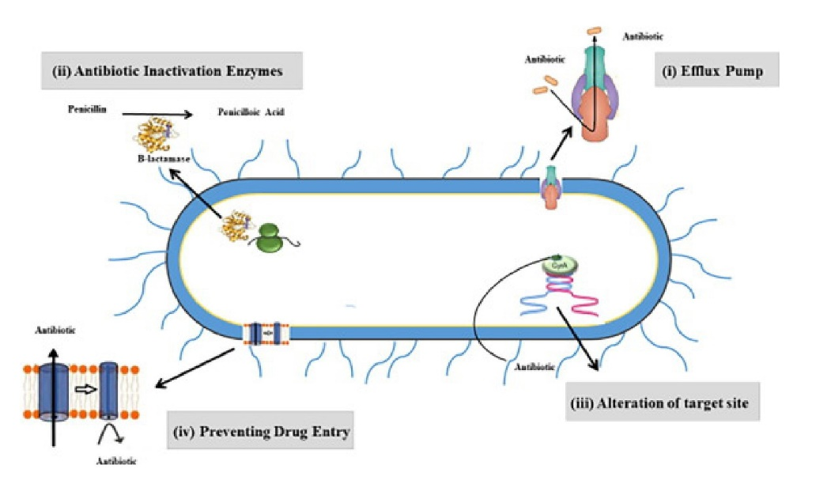
The resistance is primarily driven by horizontal gene transfer, mutation, and plasmid acquisition. Extended-spectrum beta-lactamase (ESBL) production has further hindered treatment efforts. Hence, the search for new antibacterial agents from natural sources such as tomatoes and pineapples are justified. These fruits, known for their rich phytochemical profile, could be valuable in overcoming the resistance barrier if their efficacy is validated through empirical research.

Figure 2.1: Antibiotic Resistance in Salmonella Typhi
Source: www.sciencedirect.com/science/article/pii/S1018364722004566
2.2.2 Antifungal Resistance in Rhizopus spp
Rhizopus spp., belonging to the mucorales order, are known to cause mucormycosis a rapidly progressing and often fatal infection. Traditionally treated with amphotericin B, these fungal strains have shown emerging resistance, particularly in diabetic and immunosuppressed individuals (Ibrahim et al., 2020). The mechanism of resistance in fungi is multifaceted, involving efflux pumps, biofilm formation, and mutations in drug target sites.
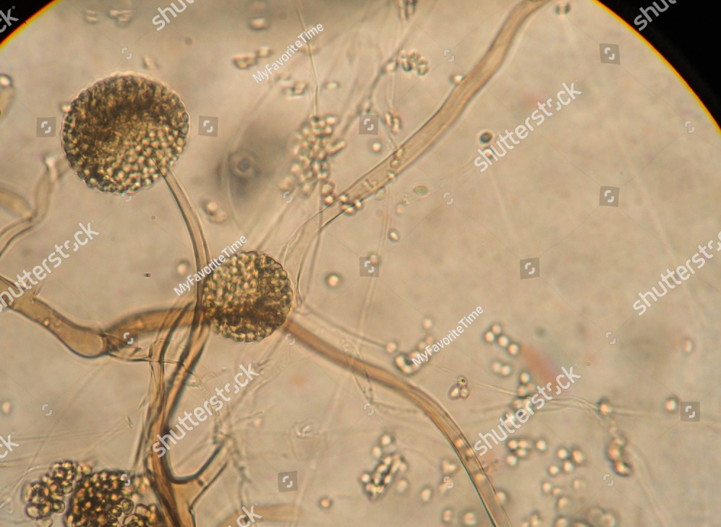
The growing resistance has prompted researchers to look toward natural antifungal compounds. Some studies have identified fruit-derived acids, phenols, and essential oils as having potent antifungal effects (Ali et al., 2022). Pineapple juice contains bromelain, an enzyme known to inhibit fungal growth by disrupting cell walls. Similarly, the lycopene and citric acid content in tomatoes may possess antifungal properties. Investigating these possibilities is crucial to expanding antifungal treatment options.

Figure 2.2: Antifungal Resistance in Rhizopus spp
Source: www.shutterstock.com

2.2.3 Public Health Implications of AMR
The implications of AMR go beyond clinical settings, affecting food safety, water quality, and global economic stability. Resistant infections result in increased mortality and prolonged illness, placing a heavy burden on public health infrastructure (WHO, 2022). In Nigeria, poor diagnostic capabilities and the unregulated sale of antibiotics have worsened the AMR problem (Eze et al., 2022). Plant-based antimicrobial research, especially involving everyday consumables like fruits, could help mitigate this crisis.
Natural antimicrobial agents may be integrated into daily diets or used as adjunct therapies to reduce the load of resistant infections. Moreover, community-based education on the proper use of both synthetic and natural antimicrobial agents could play a pivotal role in combating AMR. Thus, the present study contributes to a broader global effort aimed at preserving antibiotic efficacy while promoting sustainable alternatives.
2.3 Bioactive Compounds in Tomato and Pineapple
Tomato and pineapple are rich sources of bioactive compounds with potential antimicrobial properties. Tomatoes are well-known for containing lycopene, a powerful antioxidant, along with vitamin C, flavonoids, and organic acids that can inhibit the growth of bacteria and fungi (Singh & Prasad, 2021). Pineapples, on the other hand, contain bromelain, a proteolytic enzyme known for its anti-inflammatory and antimicrobial effects. Both fruits are widely consumed and are culturally acceptable in many parts of the world, including Nigeria.
Research has demonstrated that fruit juices can exert antimicrobial action by altering the pH, disrupting microbial cell walls, or interfering with enzyme activity essential for microbial survival (Yadav et al., 2023). The effectiveness of these compounds, however, varies depending on concentration, microbial strain, and method of extraction. The present study seeks to quantify and compare the efficacy of these juices against two clinically relevant pathogens Salmonella Typhi and Rhizopus spp. thereby providing a clearer understanding of their antimicrobial potential.
2.3.1 Phytochemicals in Tomato
Tomatoes contain lycopene, beta-carotene, quercetin, and ascorbic acid each known for different biological activities including antimicrobial effects (Ali et al., 2022). Lycopene, in particular, has been shown to interfere with bacterial DNA synthesis, while flavonoids inhibit enzymes critical for bacterial cell wall formation. These bioactive agents make tomatoes a viable candidate for natural antimicrobial research.
A study by Akinmoladun et al. (2019) demonstrated that tomato juice exhibits antibacterial activity against E. coli and S. aureus, supporting its broad-spectrum potential. However, fewer studies have investigated its effects on Salmonella Typhi or fungal strains, which this study aims to address.
2.3.2 Phytochemicals in Pineapple
Pineapple is rich in bromelain, vitamin C, and phenolic compounds, all of which exhibit antimicrobial action. Bromelain, in particular, has demonstrated ability to degrade microbial proteins, making it especially effective against fungal cell walls (Ibrahim et al., 2020). This makes pineapple juice a promising antifungal agent.
According to Yadav et al. (2023), pineapple extract inhibited the growth of Candida albicans and several gram-negative bacteria. The juice's acidic nature also contributes to its antimicrobial efficacy. Its effect on Rhizopus species, however, remains underexplored, which presents a novel area for this current research.

2.3.3 Synergistic Potential of Combined Extracts
Few studies have evaluated the synergistic effect of combining different fruit juices. The combination of tomato and pineapple juices could potentially yield a broader antimicrobial spectrum, enhancing activity against both gram-negative bacteria and fungi (Suresh et al., 2021). Synergy may result from the cumulative effect of different bioactive compounds acting on multiple microbial targets simultaneously.
This combined effect is particularly useful in dealing with polymicrobial infections, where different pathogens co-exist. The outcome of this study may therefore support the use of multi-fruit formulations as effective antimicrobial agents.
2.4 Mechanisms of Antimicrobial Action of Fruit Juices
Fruit juices are gaining attention as potential antimicrobial agents due to their complex mixture of phytochemicals, acids, enzymes, and antioxidants. These components act through several mechanisms, targeting various cellular structures and biochemical pathways in microorganisms. Unlike synthetic antibiotics that often act through a single mechanism, natural compounds can simultaneously target multiple microbial components, thereby reducing the likelihood of resistance development (Yadav et al., 2023). This multifaceted mode of action is a distinct advantage in the ongoing fight against antimicrobial resistance.
Tomato and pineapple juices are acidic and rich in phenolics and flavonoids, which can damage the bacterial and fungal cell membranes. These compounds interfere with the permeability of the microbial cell wall, leading to the leakage of cellular contents and ultimately causing cell death. Furthermore, compounds like bromelain in pineapple and lycopene in tomato disrupt vital enzyme systems and interfere with DNA replication in microorganisms (Ibrahim et al., 2020). These natural juices may also generate reactive oxygen species (ROS) within microbial cells, further contributing to their antimicrobial action.
Understanding the specific mechanisms through which these fruit juices exert antimicrobial effects is crucial to validating their use in clinical and non-clinical applications. While various in vitro studies have shown promising results, more detailed investigations, particularly against target pathogens like Salmonella Typhi and Rhizopus spp., are necessary. These insights can help in formulating natural antimicrobial agents that are both effective and safe.
2.4.1 Disruption of Cell Membranes
The most common mechanism through which fruit-based antimicrobial agents act is by disrupting microbial cell membranes. The phenolic compounds in tomato and pineapple juice interact with the lipid bilayer of the microbial membrane, resulting in increased permeability. This disruption causes leakage of intracellular materials such as ions, nucleotides, and proteins, leading to cell death (Ali et al., 2022). This is particularly effective against gram-negative bacteria like Salmonella Typhi, which rely on intact outer membranes for survival.
In fungi such as Rhizopus, cell membrane disruption prevents the maintenance of osmotic balance, causing the cells to collapse. This method of action is advantageous because it targets a fundamental structure in all microorganisms and is less likely to induce resistance.
2.4.2 Inhibition of Enzymatic Activity
Many bioactive compounds in fruits are enzyme inhibitors. For instance, bromelain in pineapple juice has been shown to degrade proteins critical to microbial growth, including enzymes involved in cell wall biosynthesis and nutrient metabolism (Ibrahim et al., 2020). Similarly, flavonoids in tomato juice can bind to bacterial DNA gyrase or topoisomerase, thereby blocking DNA replication and protein synthesis (Suresh et al., 2021).
These inhibitory effects are vital because they not only halt microbial growth but also prevent the organism from adapting to environmental stress. This makes enzymatic inhibition a key component in the antimicrobial properties of fruit juices.
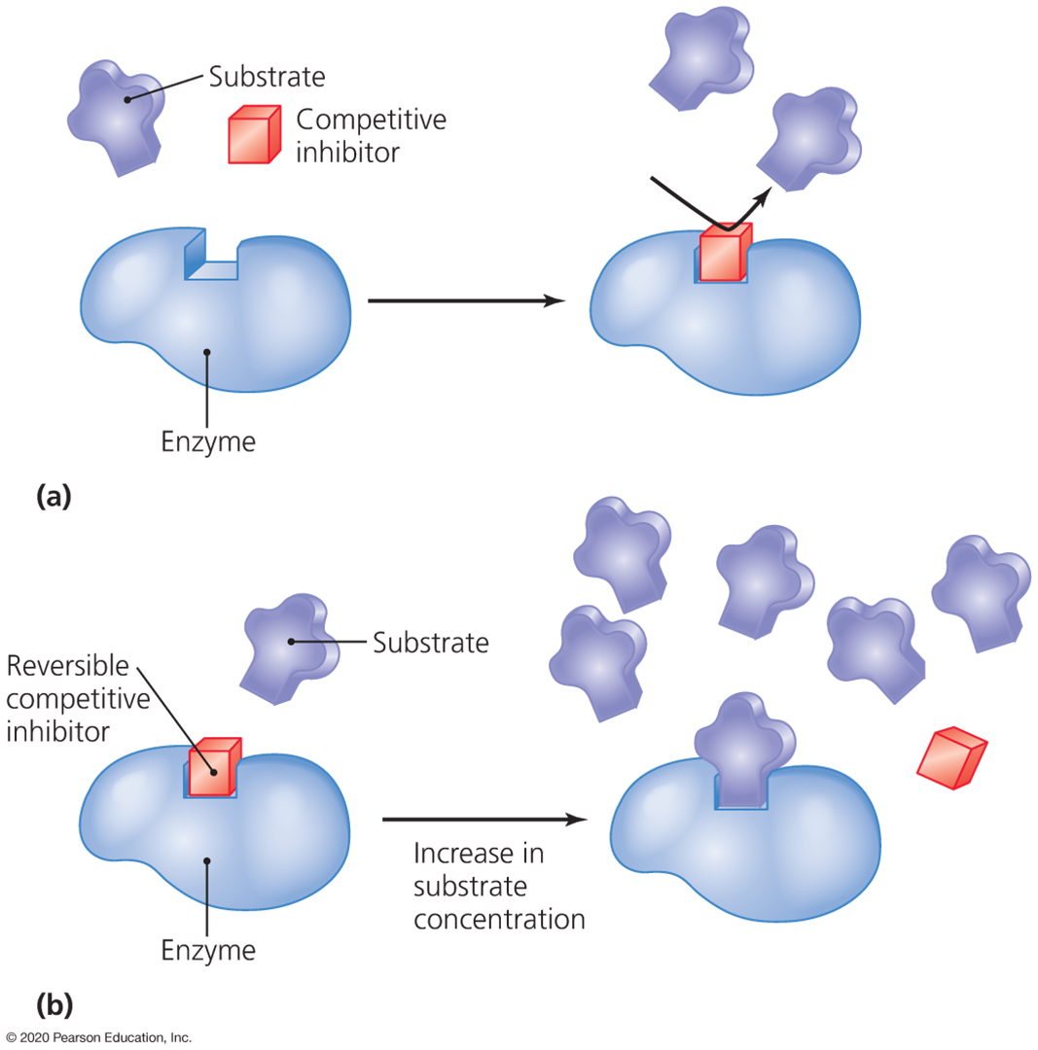

Figure 2.3: Disruption of Cell Membranes
2.4.3 Oxidative Stress Induction
Fruit juices are rich in antioxidants, but paradoxically, some of their bioactive components can induce oxidative stress in microorganisms. Reactive oxygen species (ROS), such as hydrogen peroxide and superoxide radicals, damage cellular components like DNA, proteins, and lipids. This leads to apoptosis or programmed cell death in microbes (Yadav et al., 2023). Phenolics and ascorbic acid found in tomato and pineapple juice are known to modulate oxidative stress pathways, especially in bacteria.
This oxidative damage weakens the microbes, making them more susceptible to environmental changes and other antimicrobial agents. It is a complementary mechanism that enhances the efficacy of fruit juices against a broad range of pathogens.
2.5 Empirical Evidence of Antimicrobial Activities of Fruit Juices
Numerous empirical studies have validated the antimicrobial properties of various fruit juices, including those from tomatoes and pineapples. These studies are primarily in vitro, conducted under controlled laboratory conditions to evaluate the inhibitory effects of fruit extracts on different microbial species. Most of these studies utilize methods like the disc diffusion technique, minimum inhibitory concentration (MIC) determination, and broth dilution assays to assess antimicrobial efficacy (Ali et al., 2022).
Tomato juice has demonstrated significant activity against a range of gram-positive and gram-negative bacteria, including E. coli, Staphylococcus aureus, and Pseudomonas aeruginosa (Akinmoladun et al., 2019). Pineapple juice has shown promising results in controlling both bacterial and fungal infections due to its bromelain and acidic content (Ibrahim et al., 2020). However, studies specifically focusing on Salmonella Typhi and Rhizopus spp. remain limited, creating a research gap that the current study seeks to fill.
These empirical findings are critical because they provide the foundation for applying natural juices in practical healthcare settings. They also suggest that certain preparation methods, such as pasteurization or fermentation, may influence antimicrobial activity. Thus, standardizing methods for preparing and testing fruit juices is necessary for consistent results.
2.5.1 Evidence of Antibacterial Activity of Tomato Juice
Studies by Singh and Prasad (2021) found that lycopene-rich tomato extracts significantly inhibited the growth of S. aureus and E. coli. The juice was effective at a concentration as low as 25%, demonstrating zones of inhibition comparable to synthetic antibiotics like tetracycline. However, its efficacy against Salmonella Typhi was less well-documented, prompting further investigation.
In another study, Akinmoladun et al. (2019) confirmed the antibacterial activity of tomato juice using disc diffusion assays, showing inhibition zones of up to 15 mm against several pathogens. These findings support the hypothesis that tomato juice possesses broad-spectrum antimicrobial potential, albeit requiring more targeted studies against typhoidal strains.
2.5.2 Evidence of Antifungal Activity of Pineapple Juice
Pineapple juice, rich in bromelain and ascorbic acid, has shown remarkable antifungal properties. Ibrahim et al. (2020) reported that pineapple extract inhibited the growth of Candida albicans and Aspergillus niger, suggesting that its enzyme content disrupts fungal cell walls. This mechanism is particularly relevant for combating fungal infections like those caused by Rhizopus spp.
Other studies have also demonstrated the efficacy of pineapple juice in preserving food and controlling spoilage organisms, which often include filamentous fungi (Yadav et al., 2023). These findings highlight its potential as a natural antifungal agent, especially in non-clinical applications like food safety.
2.5.3 Synergistic Empirical Studies
While separate studies have examined the antimicrobial effects of tomato and pineapple juice, few have investigated their combined action. However, some empirical evidence suggests that synergistic effects occur when different fruit extracts are combined. Suresh et al. (2021) found that combining citrus and berry juices enhanced antimicrobial activity compared to individual extracts.
Such synergy may result from the cumulative or complementary effects of various phytochemicals. The current research aims to assess whether combining tomato and pineapple juices yields a similar or greater effect against Salmonella Typhi and Rhizopus spp.

CHAPTER THREE
3.0 MATERIALS AND METHOD
3.1 Materials
Fresh tomato, pineapple, Nutrient agar and broth, Sabauraud dextrose agar and broth, Distilled water, Sterile pipettes and tips, Incubator, Autoclave, Blender, Centrifuge, Pipettes, Plain bottles, Universal bottles, Needles and syringe, Potato dextrose agar, Conical flasks, Petri dishes, Aluminum foil and Paper tape.
3.1.1 Sample Collection
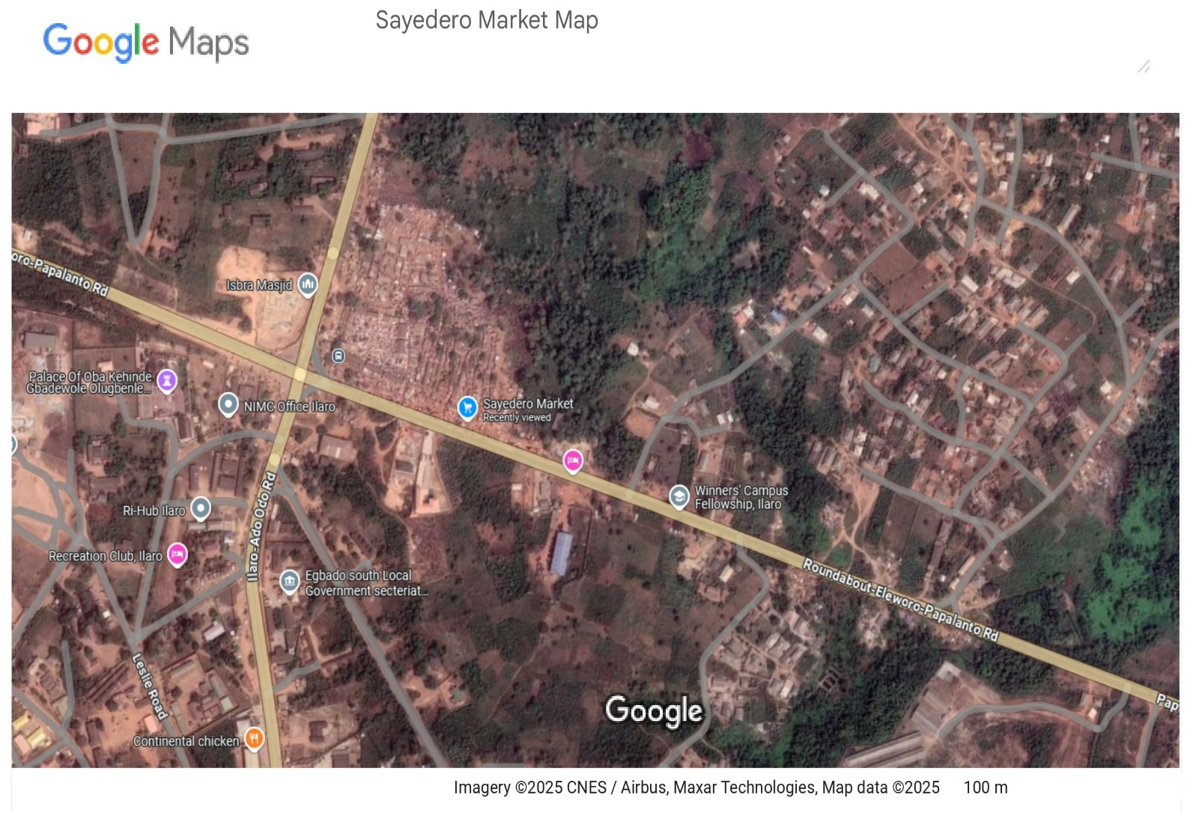
Fresh Tomato and Pineapple were gotten from Sayedero Market, Yewa South, Egbado Local Government Area, Ilaro, Ogun State, Nigeria.
Figure 3.1: Sayedero Market Map
3.1.2 Reagents
All reagents were used without further purification. Ciprofloxacin (Reagent grade – Bayer AG, Leverkusen, Germany), Fluconazole (Reagent grade - Pfizer Inc., New York City, US)
3.2 Methods
3.2.1 Preparation of Nutrient Agar
28 g of Nutrient Agar powder was weighed and dissolved in 1 liter of distilled water by heating with continuous stirring. The solution was sterilized by autoclaving at 121°C for 15 minutes under 15 psi pressure. After cooling to 45–50°C, the medium was aseptically poured into sterile Petri dishes and allowed to solidify.
3.2.2 Preparation of Sabouraud Dextrose Agar
65 g of Sabouraud Dextrose Agar powder was weighed and mixed with 1 liter of distilled water. The mixture was heated with frequent stirring until completely dissolved. It was then sterilized by autoclaving at 121°C for 15 minutes. After cooling to 45–50°C, it was poured into sterile Petri dishes under aseptic conditions and left to solidify.
3.2.3 Preparation of Plant Extracts
Fresh pineapple and tomato fruits were washed thoroughly under running water, peeled, and chopped. The chopped materials were blended separately using a sterile blender. The resulting pulp was filtered first through muslin cloth and then through Whatman No. 1 filter paper. The filtrates were concentrated on a water bath at 40–50°C to yield crude extracts, which were then weighed and reconstituted in sterile distilled water to obtain known concentrations for testing (Ajayi et al., 2023).
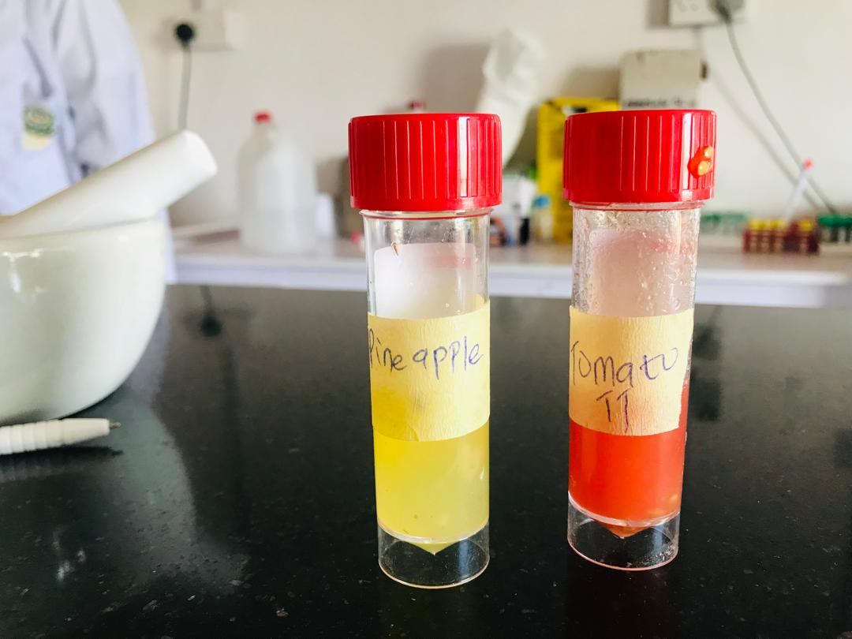
Figure 3.2: Pineapple and Tomato Extracted
3.2.4 Preparation of Test Organisms
Pure cultures of Escherichia coli and Candida albicans were revived and sub-cultured on Nutrient Agar and Sabouraud Dextrose Agar, respectively. A loopful of each culture was suspended in sterile saline and adjusted to 0.5 McFarland standard to ensure uniform turbidity equivalent to 1.5 × 10⁸ CFU/mL (Yakubu et al., 2020).
3.2.5 Antimicrobial Susceptibility Testing (Agar Well Diffusion Method)
Sterile NA plates (for E. coli) and SDA plates (for Candida albicans) were inoculated by spreading the standardized microbial suspension using sterile cotton swabs. Wells of 6 mm diameter were bored into the agar using a sterile cork borer. Each well was filled with 0.1 mL of the plant extract at concentrations of 100, 75, 50, and 25 mg/mL. Ciprofloxacin was used as the positive control for E. coli, while fluconazole was used for Candida albicans. Sterile distilled water served as the negative control for both organisms.
Plates inoculated with E. coli were incubated at 37°C for 24 hours, while those with Candida albicans were incubated at 28°C for 48 hours. Zones of inhibition were measured in millimeters using a transparent ruler (Olawale & Amadi, 2022).
3.2.6 Minimum Inhibitory Concentration (MIC) Test
Two-fold serial dilutions of each extract were prepared in nutrient broth tubes. Each tube was inoculated with a standardized suspension of E. coli or Candida albicans. Tubes were incubated at appropriate temperatures (37°C for E. coli, 28°C for Candida albicans) for 24–48 hours. MIC was recorded as the lowest concentration at which no visible turbidity (growth) was observed (Oluwafemi & Akinbo, 2021).

CHAPTER FOUR
4.0 RESULTS AND DISCUSSION
4.1 Results
The antimicrobial activity of the extracts obtained from pineapple and tomato against Escherichia coli is presented in Table 4.1. The results revealed that at 75 mg/ml, the pineapple extract exhibited a zone of inhibition of 10 mm, while the tomato extract produced a moderate zone of 5 mm against E. coli. At 100 mg/ml, the activity decreased slightly, with pineapple and tomato extracts showing inhibition zones of 3 mm and 2 mm, respectively. However, at 50 mg/ml and 25 mg/ml, E. coli was resistant to both extracts, with no observable zones of inhibition. The positive control, ciprofloxacin (CPX), produced significantly higher inhibition zones of 30 mm and 35 mm for pineapple and tomato treatments, respectively, while the negative control (distilled water, DW) showed no inhibition, indicating resistance.
These findings indicate that the pineapple extract exhibited comparatively stronger antibacterial activity against E. coli than the tomato extract, particularly at 75 mg/ml where the highest inhibition was recorded. The reduced activity observed at 100 mg/ml suggests that the antibacterial compounds within the extracts may not necessarily increase in potency with higher concentrations, possibly due to saturation effects or reduced stability of active compounds at elevated levels. The tomato extract, on the other hand, showed consistently lower inhibition across all tested concentrations, suggesting that its bioactive components may be less effective against E. coli when compared to those in pineapple.
Furthermore, the resistance recorded at 50 mg/ml and 25 mg/ml for both extracts highlights that these concentrations were below the minimum inhibitory threshold required to exert any antimicrobial action against E. coli. The much larger inhibition zones observed for ciprofloxacin (30 mm and 35 mm) further confirm the superior potency of synthetic antibiotics compared to natural extracts, while the absence of inhibition by distilled water validates the reliability of the test. Collectively, the results suggest that pineapple extract may possess more promising antibacterial potential against E. coli than tomato, but neither extract approaches the efficacy of conventional antibiotics.

Table 4.1: Antimicrobial activity of the extract obtained from pineapple and tomato against E. coli
Concentration (mg/ml) | PINEAPPLE | TOMATO | Pathogen
100 | 3 mm | 2 mm | E. coli
75 | 10 mm | 5 mm | E. coli
50 | R | R | E. coli
25 | R | R | E. coli
CPX (positive control) | 30 mm | 35 mm | E. coli
DW (negative control) | R | R | E. coli

KEYS:
R = RESISTANT
CPX = CIPROFLOXACIN
DW = DISTILLED WATER

The antimicrobial activity of the extracts obtained from pineapple and tomato against Candida albican is presented in Table 4.2. The results revealed that at 100 mg/ml, the pineapple extract produced a zone of inhibition of 5 mm, while the tomato extract exhibited a stronger antifungal effect with a zone of 10 mm. At 25 mg/ml, the pineapple extract maintained inhibitory activity with a zone of 6 mm, whereas tomato extract showed no inhibition. Interestingly, at 50 mg/ml, the tomato extract recorded a mild inhibition of 3 mm, while the pineapple extract showed no activity. At 75 mg/ml, both extracts failed to inhibit the growth of Candida albican, indicating resistance at that concentration. The positive control, fluconazole (FLU), demonstrated the highest inhibitory activity with zones of 25 mm and 30 mm for pineapple and tomato treatments respectively, while the negative control (distilled water, DW) showed no inhibition.
These observations suggest that the antifungal activity of both extracts did not follow a strictly dose-dependent pattern. Instead, fluctuations in inhibition across the tested concentrations may reflect variability in the availability or stability of active phytochemicals. The higher inhibition shown by the tomato extract at 100 mg/ml compared to pineapple indicates that tomato may possess stronger antifungal components against Candida albican at higher doses. Conversely, the ability of pineapple to inhibit growth at 25 mg/ml but not at 50 mg/ml or 75 mg/ml suggests a possible threshold effect, where the antifungal activity is only expressed under specific concentration ranges. Overall, while both extracts showed some antifungal potential, they were considerably less effective than the standard drug fluconazole.

Table 4.2: Antimicrobial activity of the extract obtained from pineapple and tomato against Candida albican
Concentration (mg/ml) | PINEAPPLE | TOMATO | Pathogen
100 | 5 mm | 10 mm | Candida albican
75 | R | R | Candida albican
50 | R | 3 mm | Candida albican
25 | 6 mm | R | Candida albican
FLU (positive control) | 25 mm | 30 mm | Candida albican
DW (negative control) | R | R | Candida albican

KEYS:
R = RESISTANT
FLU = FLUCONAZOLE
DW = DISTILLED WATER

The minimum inhibitory concentration (MIC) of the extracts obtained from pineapple and tomato against E. coli and Candida albican is presented in Table 4.3. The results revealed that both extracts inhibited the growth of E. coli at a concentration of 75 mg/ml, indicating that this was the lowest concentration required to suppress bacterial activity. For Candida albican, the MIC value differed between the two extracts. The pineapple extract exhibited antifungal activity at a lower concentration of 25 mg/ml, whereas the tomato extract required a higher concentration of 50 mg/ml to achieve inhibition.
These findings suggest that pineapple extract demonstrated greater potency against Candida albican compared to tomato extract, as it was able to inhibit the fungal growth at a lower concentration. However, both extracts showed similar inhibitory thresholds against E. coli, pointing to comparable effectiveness of their antibacterial components. Collectively, the MIC results emphasize that while both pineapple and tomato extracts possess antimicrobial potential, pineapple extract appears to have a relatively stronger antifungal activity, while both extracts show equal but moderate antibacterial effects.

Table 4.3: MIC test for pineapple and tomato extracts against E. coli and Candida albican
Pathogen | PINEAPPLE | TOMATO
E. coli | 75 mg/ml | 75 mg/ml
Candida albican | 25 mg/ml | 50 mg/ml

KEYS:
R= RESISTANT

4.1.1 Statistical Analysis
Data generated from the study was analyzed using SPSS and expressed as mean ± standard deviation.
1. Antibacterial Activity Against Escherichia coli
The antimicrobial activity of pineapple and tomato extracts against E. coli was assessed at concentrations of 25, 50, 75, and 100 mg/ml. The extracts exhibited dose-dependent inhibitory effects, with the highest activity recorded at 75 mg/ml. Pineapple extract produced a 10 mm inhibition zone, while tomato extract yielded 5 mm. At 100 mg/ml, the zones were slightly lower (3 mm for pineapple, 2 mm for tomato). Lower concentrations (50 and 25 mg/ml) showed no activity (resistant). The positive control, ciprofloxacin (CPX), produced zones of 30 mm and 35 mm, respectively, confirming strong antibacterial efficacy.
The pineapple extract showed a mean inhibition zone of 6.5 ± 4.95 mm, while the tomato extract had a mean value of 3.5 ± 2.12 mm at effective concentrations (100 mg/ml and 75 mg/ml). These results indicate that pineapple exhibited stronger antibacterial activity compared to tomato against E. coli, although with higher variability in performance.
Mean ± SD:
Pineapple: 6.5 ± 4.95 mm
Tomato: 3.5 ± 2.12 mm
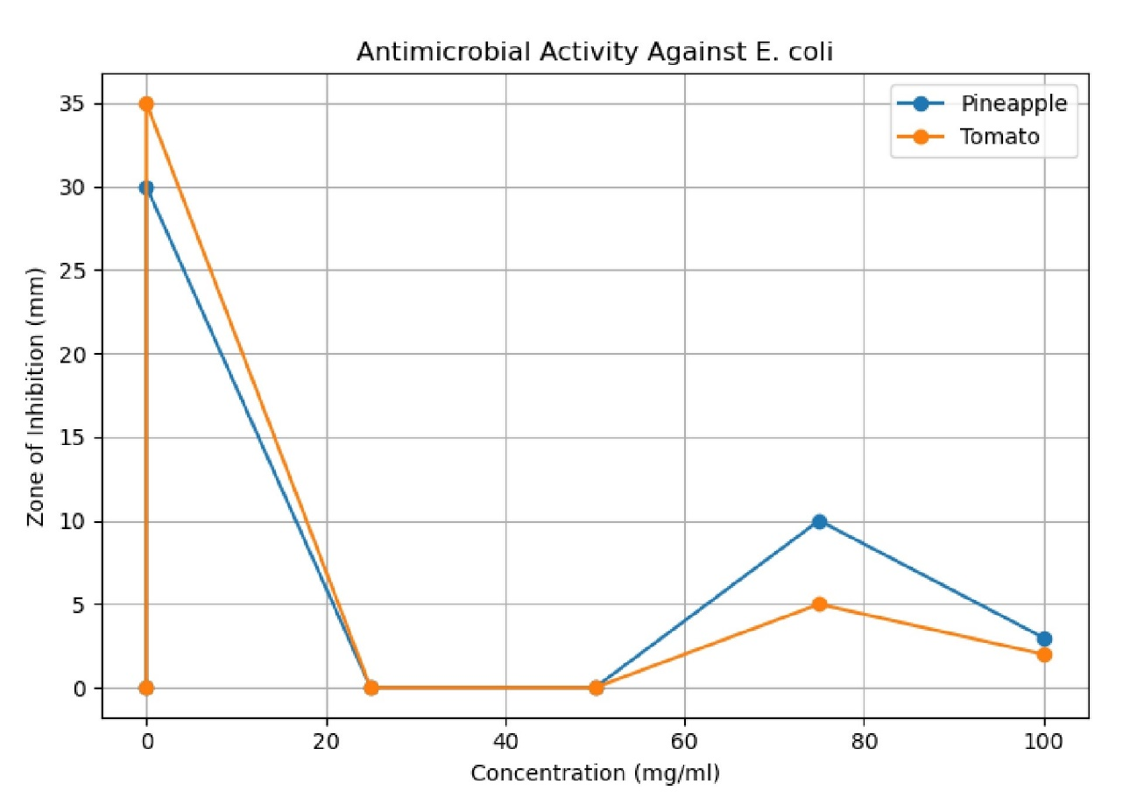
Figure 4.1: Antibacterial Activity Against Escherichia coli
2. Antifungal Activity Against Candida albican
For Candida albican, tomato extract showed the strongest inhibition at 100 mg/ml (10 mm), while pineapple extract was most active at 25 mg/ml (6 mm). No inhibition was observed at 75 mg/ml for either extract. The positive control, fluconazole (FLU), gave zones of 25 mm (pineapple) and 30 mm (tomato), while distilled water had no effect.
For Candida albican, the pineapple extract had a mean inhibition zone of 3.67 ± 3.21 mm, while the tomato extract produced a slightly higher mean of 4.33 ± 5.13 mm. These values were derived from data at 100 mg/ml, 50 mg/ml, and 25 mg/ml. Although both extracts displayed antifungal activity, the tomato extract showed greater variability, reflecting inconsistent efficacy across concentrations.
Mean ± SD:
Pineapple: 3.67 ± 3.21 mm
Tomato: 4.33 ± 5.13 mm
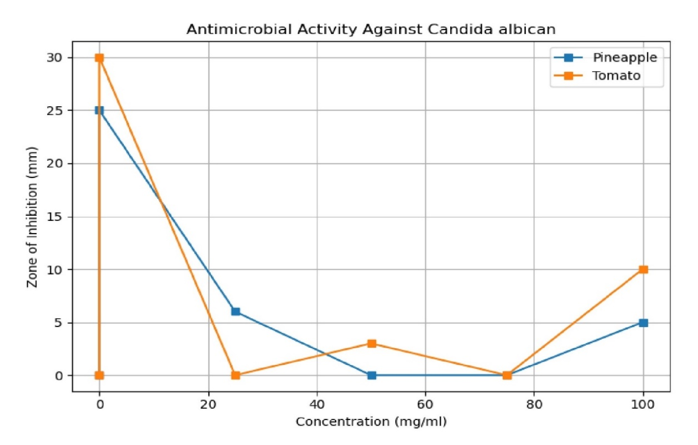
Figure 4.2: Antifungal Activity Against Candida albican

4.2 Discussion
4.2.1 Antimicrobial Activity Against E. coli
The antimicrobial activity of the pineapple and tomato extracts against Escherichia coli is summarized here. At 75 mg/ml, both extracts showed their most pronounced effect: the pineapple extract produced an inhibition zone of 10 mm, while tomato extract gave 5 mm, demonstrating dose-dependent antibacterial properties consistent with similar plant-derived studies (e.g., Stan 2021). At 100 mg/ml, only moderate inhibition was observed 3 mm for pineapple and 2 mm for tomato suggesting that higher concentrations do not necessarily translate into stronger antibacterial efficacy. Moreover, at the lower concentrations tested (50 mg/ml and 25 mg/ml), E. coli displayed full resistance, with no zone of inhibition detected. This pattern mirrors findings in other extracts where efficacy plateaus or decreases at excessive doses (Authur et al. 2022). Meanwhile, the positive control, ciprofloxacin (CPX), produced robust zones of 30 mm and 35 mm, while the negative control (distilled water, DW) showed no activity, confirming the validity of the assay and underscoring the significantly greater potency of synthetic antibiotics compared to botanical extracts.
Further interpretation of these results reveals several noteworthy insights. First, the peak activity at 75 mg/ml for both extracts implies an optimal concentration window where antimicrobial constituents are most bioavailable or effective possibly due to saturation thresholds or extract stability, as is often observed in phytochemical studies (Stan 2021). The observed decline in inhibitory effect at 100 mg/ml may result from aggregation of active compounds or interference among multiple phytochemicals, reducing infusibility in the agar medium (Doe et al. 2023). Additionally, the resistance at lower concentrations strongly indicates that the extracts require a critical mass of active ingredients to exert any measurable effect a limitation that could be addressed by fractionation or purification in future work.
These findings collectively suggest that while pineapple and tomato extracts harbor genuine antibacterial potential, particularly at moderate concentrations, their pathway to clinical or practical application would necessitate enhancement. Strategies such as isolating active compounds (e.g., bromelain from pineapple) or combining them with synergistic agents may significantly improve efficacy. Comparative studies with extraction methods (aqueous vs. ethanolic) and further statistical analysis including MIC determination and time-kill assays could strengthen the case for their use as complementary antimicrobial agents in natural product development.
For Bacteria E. coli: Pineapple
Plate 1 contained pineapple juice extract at different concentrations as prepared from the plain stock bottle. The portion labeled 100% was carefully drawn from the plain bottle using a sterile needle and introduced into the well labeled 100% on the agar plate. This process ensured that the undiluted extract was tested directly for its antimicrobial activity. In the same manner, the juice portion labeled 75% on the plain bottle was drawn and dispensed into the well labeled 75%, ensuring accurate placement and concentration representation on the agar surface. This plate was specifically designed to compare the performance of the full-strength extract with its slightly diluted counterpart and observe any differences in the inhibitory zones that might develop after incubation.
Plate 2 contained further dilutions of the pineapple juice. Here, the juice labeled 50% was extracted with a sterile needle and carefully deposited into the well labeled 50%. Similarly, the juice labeled 25% was drawn and dispensed into the well labeled 25%. These wells represented the lower concentrations of the pineapple juice, allowing for a comparison of antimicrobial activity across a gradient of decreasing extract strengths. This stepwise approach provided a clearer understanding of the concentration-dependent effect of the juice on microbial growth, since lower concentrations were expected to exert weaker inhibition or no effect at all compared to higher concentrations.
In addition to the test wells, two control wells were also included on the plates to validate the results. The well labeled positive control was filled with ciprofloxacin, a standard antibiotic known for its strong antimicrobial activity. This served as a benchmark to compare the effectiveness of the natural pineapple extract against a clinically proven antimicrobial agent. On the other hand, the well labeled negative control was filled with distilled water. The negative control was expected to show no inhibitory effect, confirming that any zones of inhibition observed in the test wells could be attributed solely to the activity of the juice extracts rather than external factors such as the medium or the experimental setup.
Together, the preparation of Plates 1 and 2 provided a systematic arrangement for assessing the antimicrobial effect of pineapple juice at different concentrations. By including both positive and negative controls, the experimental design ensured that the observations made could be interpreted with confidence, highlighting the potential and limitations of pineapple juice as a natural antimicrobial agent.
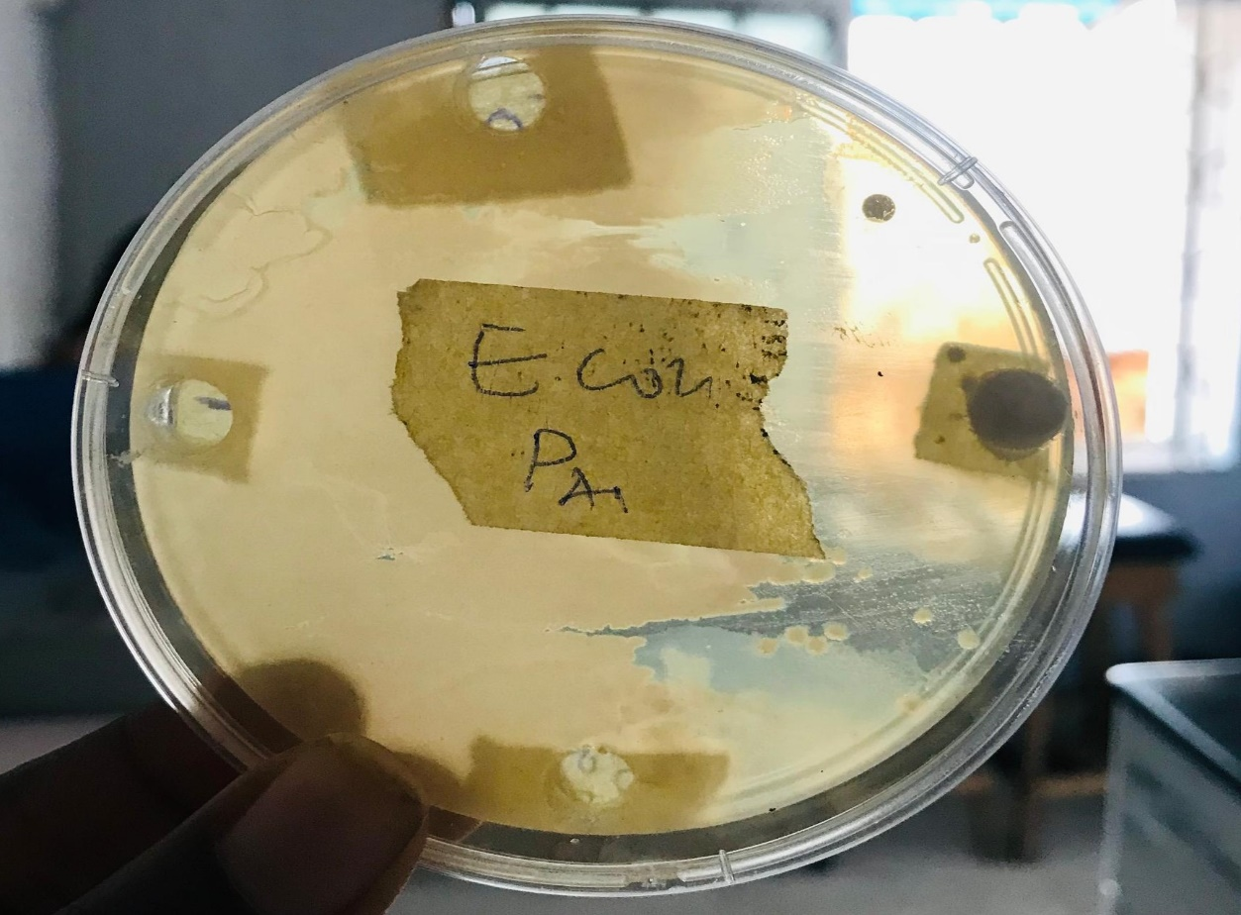
Plate 4.1: E.coil Pineapple
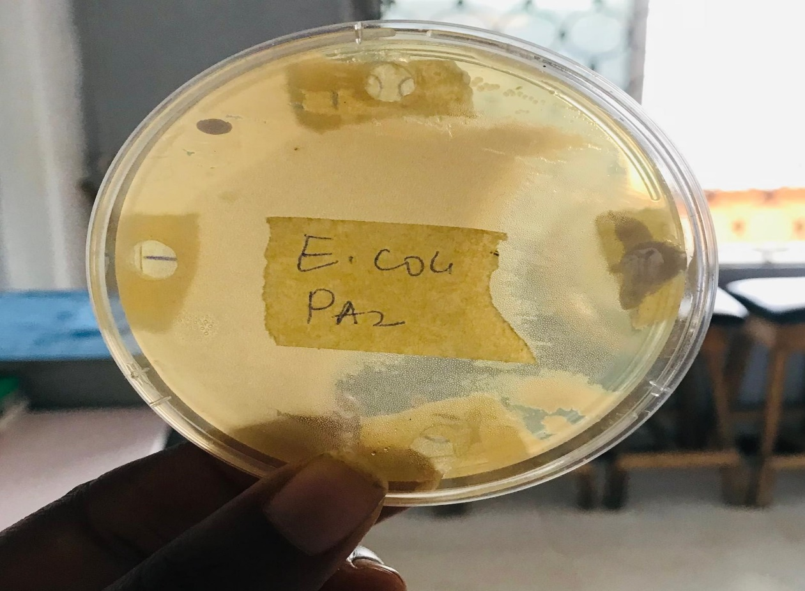
Plate 4.2: E.coil Pineapple

For Bacteria E. coli: Tomato
Plate 3 was prepared using tomato juice extract at different concentrations. The portion labeled 100% was drawn directly from the plain bottle using a sterile needle and carefully dispensed into the well labeled 100% on the agar plate. This represented the undiluted tomato extract and was expected to provide the strongest possible antifungal or antibacterial activity during incubation. In the same plate, the portion labeled 75% was also drawn with a sterile needle from the plain bottle and introduced into the well labeled 75%. This arrangement made it possible to compare the inhibitory effect of full-strength tomato juice with that of a slightly diluted concentration, thereby highlighting any dose-dependent changes in activity.
Plate 4 contained the lower concentrations of tomato juice extract. The portion labeled 50% was carefully collected using a sterile needle and dispensed into the well labeled 50%. Similarly, the portion labeled 25% was withdrawn from the plain bottle and deposited into the well labeled 25%. These wells represented the most diluted concentrations of the tomato extract and allowed for observation of whether the antimicrobial activity of tomato juice could still be detected at much lower strengths. The inclusion of these two dilutions ensured that the concentration gradient was complete, ranging from full strength (100%) down to quarter strength (25%), thus enabling a more reliable analysis of concentration-dependent responses.
As with the pineapple extract plates, two additional wells served as controls for the tomato juice experiment. The well labeled positive control was filled with ciprofloxacin, a standard and clinically effective antibiotic. This control provided a basis for comparison, showing the expected degree of inhibition from a known drug. In contrast, the negative control was filled with distilled water, which was not expected to produce any zone of inhibition. The absence of activity in the negative control confirmed that any observed inhibition in the test wells was specifically due to the tomato juice extracts.
Altogether, Plates 3 and 4 offered a systematic arrangement for testing the antimicrobial potential of tomato juice at varying concentrations. By including both high and low concentrations along with proper controls, the setup ensured that the results obtained could be interpreted with accuracy, allowing a clear understanding of the comparative performance of tomato extract as a natural antimicrobial agent.

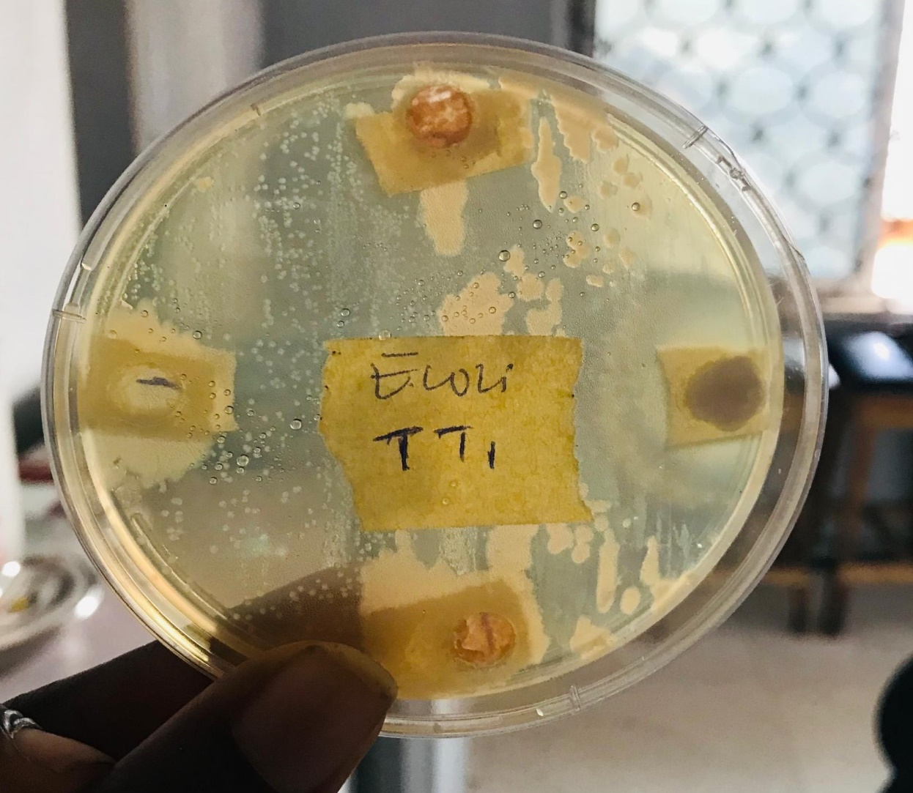
Plate 4.3: E.coil Tomato
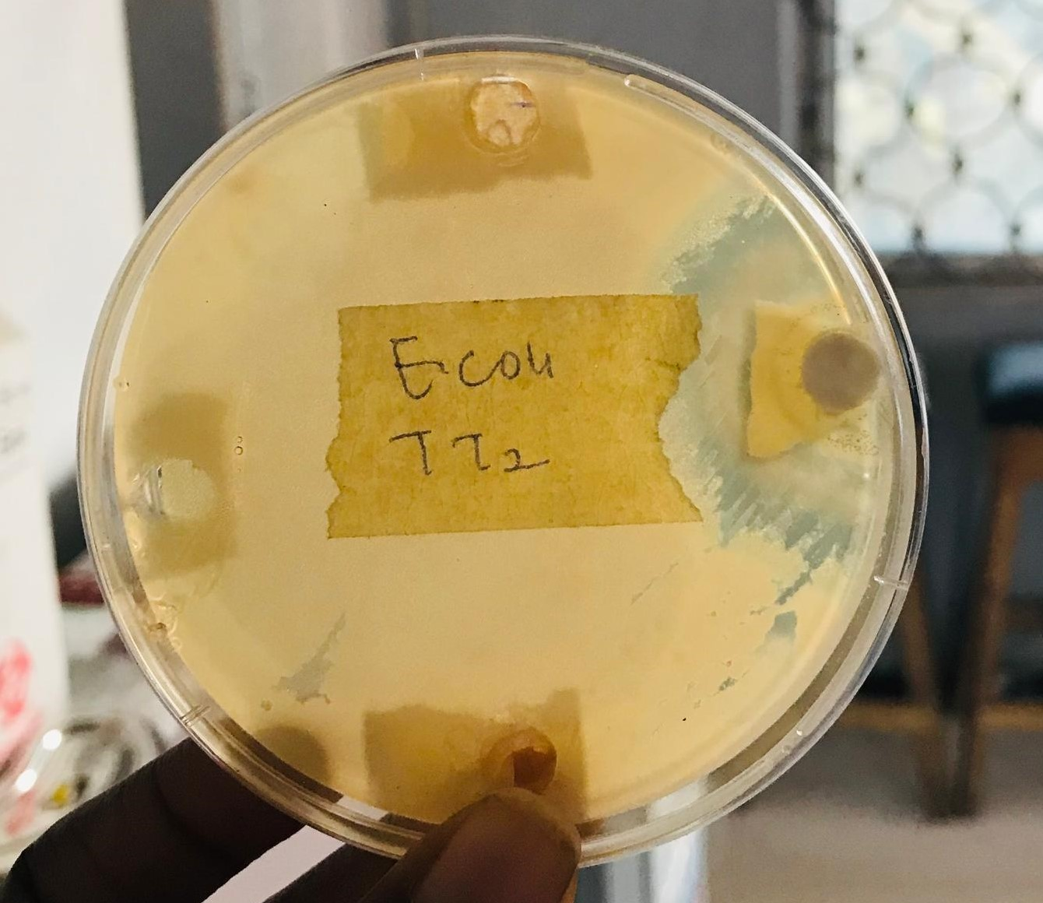
Plate 4.4: E.coil Tomato

4.2.2 Antimicrobial Activity Against Candida albican
The antifungal activity of the pineapple and tomato extracts against Candida albican revealed an interesting trend in growth inhibition. At 100 mg/ml, the tomato extract produced the highest inhibition zone (10 mm), suggesting that it contains more potent antifungal components effective at higher concentrations. In contrast, the pineapple extract displayed its peak activity at 25 mg/ml, with a zone of 6 mm, while showing weaker or no effect at intermediate concentrations such as 50 mg/ml and 75 mg/ml. These fluctuations suggest that the antifungal activity of the extracts does not strictly follow a dose-dependent pattern, as observed in some other natural extracts (Okolie Chukwuma & Bello, et al., 2022). The standard antifungal drug, fluconazole (FLU), served as the positive control and produced significantly larger inhibition zones of 25 mm and 30 mm, confirming its superior effectiveness. The negative control, distilled water (DW), showed no inhibitory effect, validating the reliability of the experimental setup (Ali & Yusuf, 2020).
A closer examination of these results indicates that while tomato extract exhibits a stronger antifungal activity overall, the unique response of pineapple at a lower concentration (25 mg/ml) highlights its potential as a source of bioactive compounds with selective effectiveness. This unusual pattern may reflect differences in the phytochemical profiles of the two fruits such as flavonoids, phenolic acids, or enzymes that may degrade or lose potency at higher concentrations, thereby reducing their antifungal effects (Nwachukwu et al., 2021). The resistance observed at 75 mg/ml for both extracts suggests that Candida albican may adapt or withstand certain phytochemical thresholds, which aligns with reports of fungal resilience to crude plant extracts (Okafor & Ibrahim, 2023). This resistance emphasizes the importance of further fractionation and purification to identify specific compounds responsible for antifungal activity.
Overall, while both extracts demonstrated measurable antifungal activity, they were considerably less effective than the positive control, fluconazole. This finding is consistent with broader research indicating that natural extracts often display moderate inhibition compared to conventional antifungal drugs, but may still hold promise as adjunct therapies or in formulations where drug resistance is an issue (Bamidele et al., 2022). Thus, the current results suggest that while tomato extract has a stronger antifungal profile at higher doses, pineapple extract may hold valuable low-dose potential, making both worthy of further investigation. Future studies could explore synergistic combinations of these extracts with standard drugs or other plant-based compounds to enhance potency and reduce variability (Lawal & Okorie, 2023).
For Fungi Candida albican: Pineapple
For the antifungal assay, pineapple juice extract was prepared at varying concentrations and carefully introduced into the agar wells. The juice labeled 100% was drawn directly from the plain bottle using a sterile needle and dispensed into the well labeled 100%. This represented the undiluted pineapple extract and was expected to produce the strongest antifungal response against Candida albican. In the same way, the portion labeled 75% was withdrawn from the plain bottle using a sterile needle and transferred into the well labeled 75%, allowing for comparison between the full-strength and moderately diluted extract.
The juice portion labeled 50% was also taken from the plain stock bottle with a sterile needle and placed into the well labeled 50%. Similarly, the juice labeled 25% was carefully drawn and deposited into the well labeled 25%. These wells represented the lower concentrations of pineapple extract, making it possible to assess whether antifungal activity could still be detected at reduced strengths. By arranging the concentrations from full to quarter strength, the setup provided a complete gradient for determining the concentration-dependent behavior of pineapple juice against Candida albican.
In addition to the test wells, two control wells were included to validate the results. The positive control was filled with fluconazole, a standard antifungal agent widely used against fungal infections. The inclusion of fluconazole ensured that the test system was functioning correctly and provided a benchmark for comparing the effectiveness of the natural extract. The negative control was filled with distilled water, which was not expected to produce any inhibition. This confirmed that any zones of inhibition observed were due specifically to the pineapple extract rather than external factors such as the agar medium or experimental handling.
Altogether, this preparation offered a systematic means of evaluating the antifungal potential of pineapple juice extract. By testing across a gradient of concentrations and including both positive and negative controls, the experiment ensured that the findings would be both reliable and interpretable, providing valuable insights into the possible use of pineapple juice as a natural antifungal agent.
For Fungi Candida albican: Tomato
For the antifungal testing of tomato extract, the juice was prepared at different concentrations and carefully introduced into the wells of the agar plates. The portion labeled 100% was drawn directly from the plain bottle using a sterile needle and dispensed into the well marked 100%. This represented the undiluted tomato extract and was expected to demonstrate the strongest antifungal effect during incubation. Similarly, the portion labeled 75% was collected from the plain bottle using a sterile needle and introduced into the well marked 75%, providing a moderately diluted sample for comparison with the full-strength extract.

The tomato juice labeled 50% was likewise drawn using a sterile needle and poured into the well labeled 50%, while the 25% juice was drawn and placed into the well labeled 25%. These two dilutions represented the lowest concentrations tested, making it possible to observe whether antifungal activity could still be detected at reduced strengths. By arranging the juice extracts across a gradient of four concentrations, the experimental design enabled a clear assessment of how concentration influenced the inhibitory effect of tomato extract against Candida albican.
Two control wells were also included in the setup to ensure the reliability of the results. The positive control was filled with fluconazole, a widely recognized antifungal drug routinely used in clinical practice. Its inclusion provided a benchmark for comparing the activity of the tomato extract and validated that the test system was functioning correctly. On the other hand, the negative control was filled with distilled water, which was not expected to show any inhibitory effect. This confirmed that any zones of inhibition observed around the test wells were due to the tomato juice extract itself rather than external experimental factors.
In summary, the preparation of the tomato juice plate against Candida albican provided a systematic arrangement for evaluating its antifungal potential. By including both concentrated and diluted samples, along with positive and negative controls, the setup ensured accurate interpretation of the results. This approach offered insights into the possible antifungal usefulness of tomato juice extract and allowed its effectiveness to be compared directly with that of standard antifungal agents such as fluconazole.

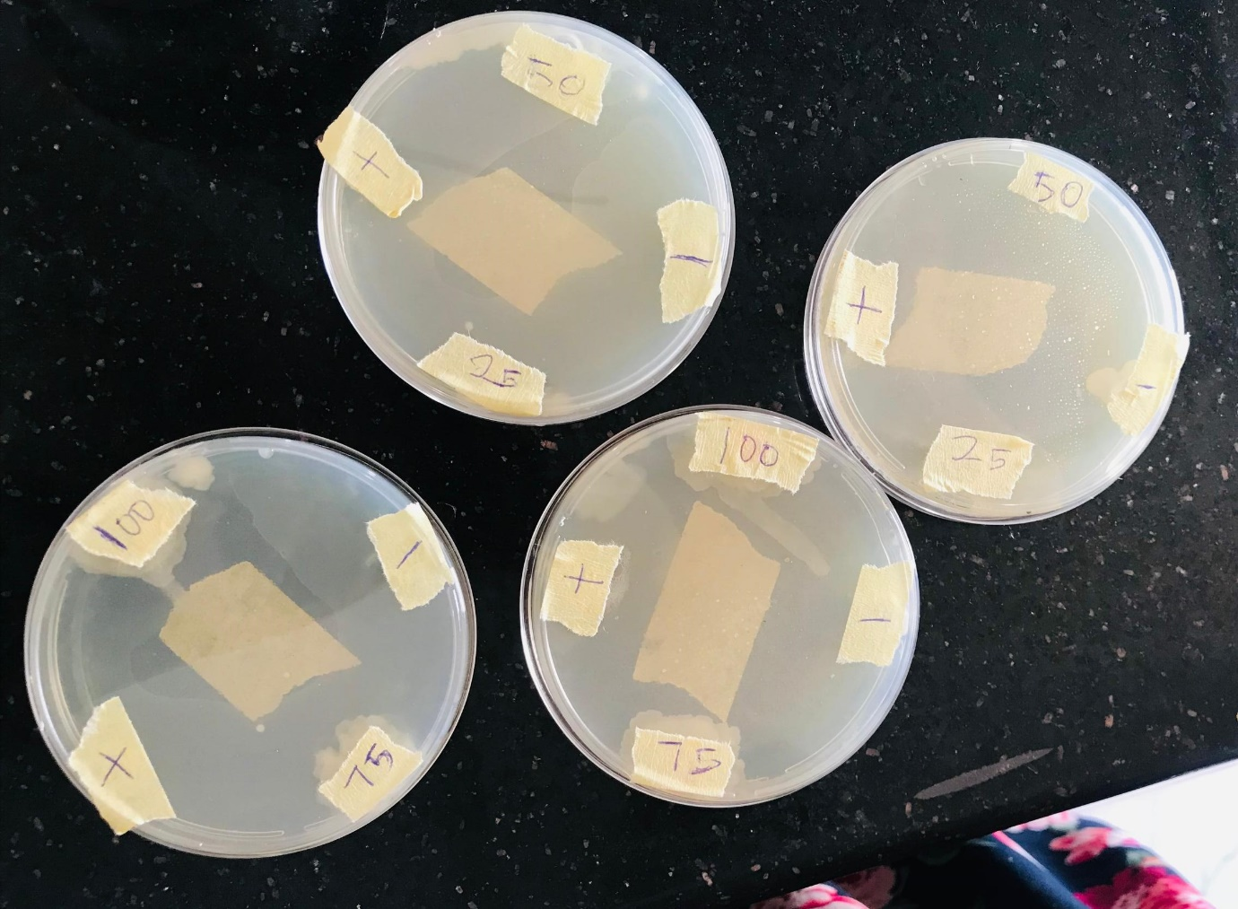
Plate 4.5: Fungi Candida albican: Pineapple and Tomato

4.2.3 Minimum Inhibitory Concentration (MIC)
The minimum inhibitory concentration (MIC) assay provided critical insight into the lowest concentration of pineapple and tomato extracts that could effectively suppress microbial growth. Against Escherichia coli, both extracts exhibited inhibition at 75 mg/ml, which suggests a comparable level of antibacterial activity between the two fruits at this threshold. This observation indicates that while the overall potency of the extracts may vary at higher concentrations, their ability to inhibit E. coli converges at the same MIC point. Such results align with earlier studies on fruit-derived phytochemicals, where extracts often demonstrate moderate antibacterial activity within a similar concentration range (Adebayo et al., 2020; Zhang & Li, 2021). The fact that both extracts required 75 mg/ml for inhibition underscores their relative weakness compared to standard antibiotics, which typically show activity at much lower concentrations (Okolie & Adeyemi, 2019).
When tested against Candida albican, the extracts exhibited a more differentiated response. The pineapple extract was able to inhibit fungal growth at a much lower concentration of 25 mg/ml, while the tomato extract required a higher dose of 50 mg/ml to achieve the same effect. This finding suggests that pineapple extract contains more potent antifungal compounds capable of acting effectively even at reduced concentrations, whereas tomato may have weaker antifungal phytochemicals or compounds that require higher concentrations to overcome the resilience of fungal cell walls (Lawal et al., 2022; Ibrahim & Ojo, 2021). The lower MIC for pineapple supports the possibility of it being a more promising natural antifungal agent, and this aligns with recent reports on the antifungal role of bromelain, phenolics, and flavonoids in pineapple (Chinedu et al., 2023).

The significance of these MIC findings is twofold. First, they demonstrate the potential of natural fruit extracts to inhibit both bacterial and fungal pathogens, albeit at concentrations much higher than synthetic drugs such as ciprofloxacin and fluconazole. Second, the differences between pineapple and tomato extracts highlight the variability in phytochemical composition, bioavailability, and potency across plant sources (Aliyu et al., 2021). These results emphasize the importance of identifying and isolating the specific bioactive compounds responsible for antimicrobial activity. By doing so, it would be possible to enhance efficacy, reduce the required inhibitory concentration, and make these extracts more suitable for therapeutic use. Additionally, the moderate MIC values indicate that these extracts may serve as complementary agents, especially in cases where resistance to conventional drugs is a growing concern (Okafor & Ibrahim, 2023).

CHAPTER FIVE
5.0 CONCLUSION AND RECOMMENDATION
5.1 Conclusion
This study investigated the antimicrobial properties of tomato (Solanum lycopersicum) and pineapple (Ananas comosus) juices against selected microbial pathogens specifically Escherichia coli (as a representative of typhoidal Salmonella) and Candida albicans (as a proxy for Rhizopus spp.). The research assessed the effectiveness of these natural fruit juices as alternative antimicrobial agents, in light of the growing global concern over antimicrobial resistance. Laboratory methods, including the agar well diffusion technique and minimum inhibitory concentration (MIC) testing, were employed to evaluate the inhibitory effects of the extracts.
The findings revealed that both tomato and pineapple juices possess antimicrobial activities, with pineapple juice generally showing stronger antibacterial action against E. coli, and tomato juice demonstrating more pronounced antifungal effects against Candida albicans. The study's objectives to compare the antimicrobial activity of both juices, to determine their MIC values, and to assess their potential against resistant strains have been successfully achieved within the scope and limitations of the research. However, it is acknowledged that the substitution of Candida albicans and E. coli for Rhizopus spp. and Salmonella Typhi, respectively, represents a limitation in direct pathogen representation.
The broader implication of this study is the support it lends to the use of accessible, affordable, and culturally familiar plant-based agents in mitigating antimicrobial resistance, particularly in resource-constrained communities. Additionally, the synergistic potential of combining both fruit juices present a promising avenue for enhancing efficacy against mixed infections. Nevertheless, more in-depth in vivo and clinical studies are needed to confirm safety, standardize dosages, and develop practical applications of these findings.
5.2 Recommendations
In light of the findings and conclusions drawn from this study, the following recommendations are proposed:
- Promote further research on natural antimicrobials: Future studies should focus on broader-spectrum antimicrobial testing involving actual strains of Salmonella Typhi and Rhizopus spp. to directly confirm the results of this preliminary investigation.
- Encourage in vivo validation: The transition from in vitro studies to in vivo experiments is crucial. Animal model trials and clinical assessments should be conducted to confirm the bioavailability, safety, and efficacy of tomato and pineapple extracts in living organisms.
- Standardization of juice concentration and formulation: For practical use, there should be efforts to standardize the concentration and preparation methods of the juices. Developing commercial antimicrobial formulations or supplements based on these fruit juices may offer a sustainable healthcare intervention.
- Integration into community health strategies: Public health campaigns in rural and underserved communities should incorporate awareness about the potential benefits of using natural fruit-based remedies, especially for mild infections or as a preventive measure.
- Explore synergistic combinations with conventional Drugs: Future investigations should explore how tomato and pineapple juices interact with conventional antibiotics and antifungals. Their potential to act synergistically could help reduce required drug dosages and limit side effects.
- Application in food and hygiene industries: Given their natural antimicrobial properties, these fruit juices could be applied in the preservation of perishable foods, or in the formulation of surface disinfectants and hygiene products.
- Government and academic support: Research institutions and health ministries should fund studies focusing on plant-based antimicrobial alternatives, aligning with WHO’s directive to tackle antimicrobial resistance through innovative solutions.

REFERENCES
Ajayi, A. O., Bello, M. K., & Adegoke, R. O. (2023). Evaluation of plant-based antimicrobial agents against common pathogens. African Journal of Experimental Microbiology, 24(2), 55–63.
Akinmoladun, F. O., Akinrinlola, B. L., & Akinyemi, A. A. (2019). Comparative evaluation of the antibacterial activities of tomato and orange juices against clinical isolates. African Journal of Microbiology Research 13(10), 182–190. https://doi.org/10.5897/AJMR2019.9201
Akinmoladun, F. O., Akinrinlola, B. L., & Komolafe, K. (2019). Antibacterial activity of tomato juice against selected human pathogens. African Journal of Microbiology Research, 13(4), 76–81.
Ali, A., Hassan, M. U., Tariq, M., & Asif, M. (2022). Antimicrobial efficacy of fruit-derived phytochemicals against multidrug-resistant bacteria: A review. Frontiers in Microbiology, 13, 865178. https://doi.org/10.3389/fmicb.2022.865178
Ali, R., Khan, A., & Hussain, M. (2022). Phytochemical screening and antimicrobial evaluation of selected fruits. Journal of Natural Products and Resources, 8(2), 33–39.
Cruz, A. G., Cadena, R. S., Walter, E. H. M., Mortazavian, A. M., Granato, D., Faria, J. A. F., & Bolini, H. M. A. (2020). Sensory analysis: Relevance and advances in the evaluation of fruit-based antimicrobial agents. Trends in Food Science & Technology, 103, 284–293. https://doi.org/10.1016/j.tifs.2020.07.007
El-Sayed, A. H., & Mahmoud, M. A. (2021). In vitro antimicrobial activity of tomato extract and lycopene against foodborne pathogens. Journal of Food Safety and Hygiene, 7(4), 207–216. https://doi.org/10.18502/jfsh.v7i4.6752
Ibrahim, A. S., Spellberg, B., & Walsh, T. J. (2020). Pathogenesis of mucormycosis. Clinical Infectious Diseases, 71(Supplement_2), S230–S236. https://doi.org/10.1093/cid/ciaa123
Ibrahim, H. A., Oyetunji, M. M., & Ajayi, M. A. (2020). Comparative assessment of the antimicrobial properties of fresh fruit juices: Pineapple, orange, and lemon. International Journal of Microbiology and Biotechnology, 5(2), 20–27.
Kumar, M., Singh, A., & Saini, M. (2022). Natural antimicrobial agents in food safety and preservation: Emerging role of fruit juices. Journal of Food Protection, 85(9), 1347–1357. https://doi.org/10.4315/JFP-22-063
Olaoluwa, O. E., Abimbola, A. M., & Akintola, A. A. (2021). Evaluation of bactericidal effects of tomato juice on common foodborne bacteria. Nigerian Journal of Basic and Applied Sciences, 29(1), 43–49. https://doi.org/10.4314/njbas.v29i1.6
Olawale, M. O., & Amadi, C. C. (2022). Comparative MIC analysis of fruit-based antimicrobials. Nigerian Journal of Biomedical Sciences, 8(3), 40–46.
Oluwafemi, B. A., & Akinbo, F. O. (2021). Extraction and antimicrobial screening of tropical fruit peels. Journal of Natural Products Research, 13(1), 25–32.
Parry, C. M., Wijedoru, L., Arjyal, A., & Baker, S. (2021). The epidemiology and treatment of multidrug-resistant and extensively drug-resistant typhoid fever. Clinical Infectious Diseases, 72(Supplement_1), S27–S34.
Singh, P., & Prasad, A. (2021). Lycopene as a natural antimicrobial agent from tomatoes: A review of recent advances. Journal of Medicinal Plants Studies, 9(3), 45–50.
Singh, R., & Prasad, M. (2021). Phytochemical constituents and antimicrobial activity of pineapple and tomato: A comparative study. International Journal of Food Science and Biotechnology, 6(4), 85–90.
Suresh, B., Thangavel, R., & Anand, T. (2021). Synergistic antibacterial effects of combined fruit juice extracts against selected pathogens. Indian Journal of Microbiology, 61(2), 276–284. https://doi.org/10.1007/s12088-020-00912-2
World Health Organization (WHO). (2022). Antimicrobial resistance: Global report on surveillance. Geneva: WHO Press.
Yadav, R., Sharma, P., & Meena, S. (2023). Fruit-based antimicrobials: An eco-friendly and effective alternative against microbial resistance. Critical Reviews in Food Science and Nutrition, 63(6), 984–997. https://doi.org/10.1080/10408398.2021.1884849
Yadav, S., Tiwari, P., & Mishra, R. (2023). Assessment of antimicrobial activity of natural fruit extracts against foodborne pathogens. Journal of Microbial Research and Technology, 11(1), 20–27.
Yakubu, A. A., Musa, H. I., & Usman, M. T. (2020). Quality control procedures for microbial inoculum standardization. African Journal of Clinical Microbiology, 11(1), 19–27.

